

2022 STUDENT RESEARCH CASE STUDY CHALLENGE

Football/Soccer

March 25, 2022

The A TEAM | uNIVERSITY OF NEW SOUTH WALES | LECTURER: XIAO XU

ZACHARY SEGGER | YEN HUE TRAN | RAYMOND CHAN | SARAH MORGAN | ON PUI FOC

# Executive Summary

Rarita is looking to participate in the Football and Sporting Association (FSA) League. We are hired to:

* Construct a competitive team; and
* Analyse the impact of a Football brand on Rarita’s economy over the next 10 years.

In constructing a competitive team, below were the objectives:

* Rarita ranking top ten of the FSA within the next five years; and
* Rarita having a high probability of achieving a championship within the next 10 years.

The team selected for Rarita is comprised of 5 to 8 players for each position. The team will have a 99% probability of ranking within top 10 members of the FSA for the next 5 years and 95% of probability of placing in the top 3 within the next 10 years.

Over the 10 years, the investment of 995mil Doubloons allows Rarita to construct a competitive team without additional funding. While the venture is projected to remain profitable in most scenarios, consistent poor performance or a lack of consumer interest may result in lower revenue growth and create a going concern.

# Team Selection

## Assumptions/Constraints

Moneyball popularised team selection by examining player statistics to determine value for money, assuming that the baseball labour market undervalues (or overvalues) specific player skills.[1] We applied the same underlying assumption, distinguishing between player salary and underlying player value (determined by key performance indicators). We also assumed:

|  |  |  |
| --- | --- | --- |
| # | Assumption | Justification |
| 1 | Tournament players without an identifiable league come from a local league (comparable to the RFL) | Removing RFL players from league data takes the average Rarita salary from being an outlier, to being above average compared to other nations |
| 2 | Salaries/value continually rise at 5.3% PA (superimposed inflation) | There was a 5.3% increase in average player salaries from 2020 to 2021 |
| 3 | 5 to 8 for each position with a roughly equal proportion of total value assigned to each position (except goalkeeper) | Team makeup aligns with the top 3 teams in the 2021 tournament |
| 4 | Salaries paid to tournament players for a year is equal to the annualised salary | The tournament is a yearlong commitment (despite being less games than regular season) |
| 5 | Only home-grown players should be considered | 10% surcharge on international players goes against undervaluing strategy whilst risking national pride |

More broadly, we assumed that team creation does not contravene the regulations governing the FSA. Another constraint is that the model does not consider the interaction between the players.

## Method

To determine players for the 2022 national Rarita team, we (see Appendix A for models used and Attachment A for R code with comprehensive explanations of steps):

|  |  |
| --- | --- |
| # | Step |
| **1** | Determined player's value based on playing statistics, position, and league (important indicator of the quality of opposition) |
| **2** | Maximised the total value of a team whilst constraining the total player salary, number of players in a position and proportion of allocated value for each position |
| **3** | Applied model to different salary caps to fit a polynomial equation linking salary and value |
| **4** | After establishing a strong link between underlying team value and performance (Appendix B: Figure 1), determined the probability of placing top 10 using team data from the 2021 tournament (Appendix B: Figure 2) - probabilities were found by discounting the total team value back to 2021 at the superimposed inflation rate |
| **5** | Minimised the net present value (NPV) of the total player salaries each year (includes return on investment and superimposed inflation), whilst meeting the competitiveness requirement |
| **6** | With the team budget for each year confirmed, players were selected |

To meet the competitiveness requirement, regardless of return on investment (ROI) of unspent monies, increasing spending by an order of magnitude for two of the years (in the first 5 years) is required (Appendix C). However, large player budgets in 2025 and 2026 are ideal given other considerations.[2]

* Large player salaries early in the venture is not prudent because:
  + support structures for the team are yet to be tried and tested;
  + public typically have a low expectation of performance early in the venture, however, mediocre performance following success could reduce morale and support; and
  + three years of low spending enables early validation of the model and assumptions without exposing the venture to significant risk.
* If the team proves successful in 2025 or 2026 it may garner strong national support and interest, inducing higher team investment from 2027-2031, and leading to a greater chance of future tournament success and further economic benefits.

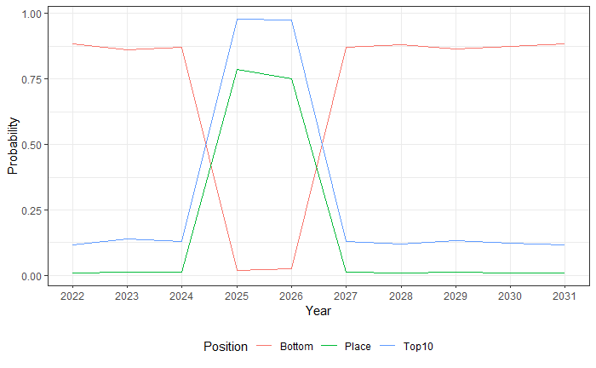Figure 1 - Corresponding probabilities of finishing top 3 (Place), top 10 including Top 3 (top 10) or outside top 10 (bottom) for tournament position using 12% ROI

# Implementation Plan

## Team

Appendix D contains the list of selected players for 2022.

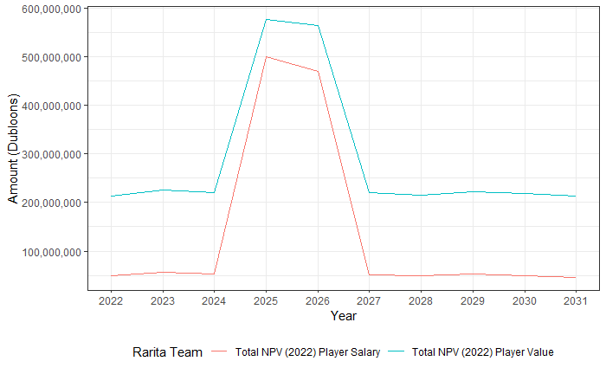Figure 2 - Total NPV of player salary and value for the next 10 years using 12% ROI

## Revenue Sources

The primary source of revenues will be the growth of viewership and interest in Rarita’s football brand, leading to increased ticket sales, merchandise sales and other commercial opportunities (e.g., sponsorships).

Secondary sources of revenue include the reinvestment of revenue and spare capital (large portion of which is the initial government funding).

## Metrics to Monitor Strategy

Key metrics to monitor the two goals include:

|  |  |  |  |
| --- | --- | --- | --- |
| # | Metric | Frequency | Rationale |
| **1** | FSA ranking | Annual | Rarita’s tournament ranking indicates competitiveness per the Commissioner’s criteria. |
| **2** | Player value | Annual | Regularly reviewing the team selection model and assumptions ensures the most appropriate players are chosen. |
| **3** | Social media followers and league attendance | Monthly | Proxies for popularity help track consumer engagement and revenue potential. |
| **4** | Other nations’ player value and in-game strategies | Bi-annual | Assessing the competition’s strengths and weakness allow Rarita to optimise team performance. |
| **5** | Revenues and expenses | Annual | The football industry must be profitable to be sustainable. |

# Economic Impacts

## Assumptions/Constraints

Revenues and expenses have been projected under three scenarios to assess the economic impact of forming a national team.

|  |  |
| --- | --- |
| # | Assumption |
| **1** | * Forming the team has no material impact (may occur if the team consistently underperforms, or if there is little consumer interest). * Revenues and expenses will grow in line with the historical average, defined as the 4-year geometric mean between 2016-2020 except for matchday revenues. * 2019-20 matchday data should be omitted to remove the effect of the COVID-19 pandemic which prevented live matches. |
| **2** | * Revenue growth will be double the historical average over the next 5 years. * Aligns with Rarita’s goal to be a top 10 team within 5 years whereby a high-value team selected in years 2025-26 will succeed in placing in the top 10 to generate greater revenues through consistent public interest and sales. |
| **3** | * Linear growth over the next 5 years up to the average revenues and expenses per capita recorded by the top 10 placing nations in 2020, before returning to the historical average growth. |

Across all scenarios, the following simplifying assumptions apply:

* Revenues and expenses grow uniformly throughout each province;
* 3.5% inflation in line with historical yearly averages (1991-2020);
* 12% ROI (per the team selection analysis); and
* At the start of each year, return on invested assets are available and salaries are paid in full.

The analysis isolates the cashflows for the football industry. In practice, related industries such as Rarita’s tourism and retail industries would be positively impacted by the creation of a competitive team. These projections can be interpreted as conservative estimates of the potential profitability of the football industry. Currently, Rarita records < 50% per capita revenues and expenses when compared to top 10 teams in 2020.

## Cash Flow Analysis

As seen in Figure 3, Rarita’s current football industry will be unprofitable from 2026 using historical average growth in revenues and expenses (scenario 1). However, projected cash flows indicate that Rarita’s football industry will remain profitable when revenue growth doubles from the historical average over the next 5 years (scenario 2).

Scenario 3 illustrates that the football industry for the top 10 teams in 2020 record substantial profits per capita, which is achievable given the competitiveness objectives.

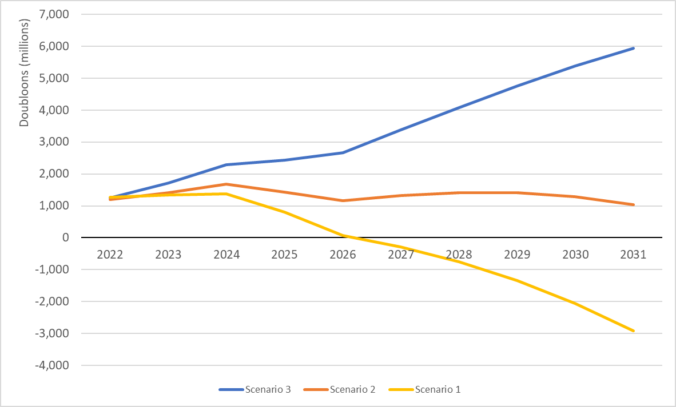Figure 3 - Projected net profits for the next 10 years

## Economic Indicators

Below are direct and indirect effects of forming a competitive team to economic indicators.

|  |  |  |  |
| --- | --- | --- | --- |
| # | Indicator | Expected Impact | Explanation |
| **1** | GDP and GNI | Increase | * Initial spend will create income for businesses, households * New team will generate tourism[3] * Potential profitable ventures such as introducing attraction spots or operating football events * Net exports from loaning players to other countries will increase GNI |
| **2** | GDP per capita | Increase | * Living standards increase as labour productivity increases * In Australia, a growing sports industry was estimated to provide a 1% GDP increase from better workforce productivity[4] |
| **3** | Inflation | Temporary increase | * Hosting sporting events will increase the demand for products and services (national team performs well can further attract international tourism) and push prices up[5] |
| **4** | Employment | Increase | * Expansion of sport industry provides more job opportunities, e.g., volunteer activities * In Australia, the sports industry was estimated to generate approximately about 90 000 full-time jobs and an additional $3 billion in economic value[6] |
| **5** | Healthcare spending | Decrease | * Promoting sport can have a benefit on health by encouraging participation in sports * In Australia, net health benefits from sport was estimated to be $29 billion per year by reducing mental health costs and improving quality of life[7] |
| **6** | Population density | Stable | * Unaffected unless there are new sporting facilities that can only be accessed by an area (unlikely as football can readily be played in different environments) |

# Risks and mitigations

Below are potential key risks resulting from the launch of the new team.

|  |  |  |  |  |
| --- | --- | --- | --- | --- |
| # | Risk | Impact | Likelihood | Explanation/Mitigations |
| **1** | Higher expenses relative to revenues | 5 | 3 | The following could impact the operation being a going concern: - Higher inflation relative to ROI; - Poor performance; - Lack of national interest (reduced revenue); - Higher staffing costs (players, coaches etc.) or other costs (rent, facilities, travel etc.).  **Mitigations**: Efficient portfolio that minimises variance of returns for selected ROI, invest in assets that perform well against rising inflation (e.g., commodities), players take part in community events, our strategy aims to build a stronger team over 5 years aligned with public expectation, social media platform |
| **2** | Health risks | 4 | 3 | There is a risk that the Rarita team brings home diseases (e.g., COVID-19 pandemic). This, alongside potential injuries or illnesses experienced by the players poses a risk for players’ health and consequently, their ability to compete.  **Mitigations**: Country brief to cover laws, culture, health advice, and safety concerns |
| **3** | International friction | 3 | 3 | There is a risk that players do not adhere to other rules or cultural values, creating frictions with other countries and impacting political relationships.  **Mitigations**: Country brief to cover laws, culture, health advice, and safety concerns. Introduce curfews or restrictions on alcohol consumption. |
| **4** | Terrorism | 4 | 2 | In competing internationally and having other teams come to Rarita, there is a risk that Rarita becomes susceptible to a terrorist attack which has social and political impacts[8].  **Mitigations**: High security at games |
| **5** | Poor culture | 2 | 4 | There is a risk that the team engages in substance abuse or that Rarita’s international competitiveness encourages sports betting, impacting Rarita’s culture and economy.  **Mitigations**: Education strategies, laws and regulations to control and monitor |

## Sensitivity Analysis

In relation to the risk of higher of expenses (risk 1), below is an analysis of the sensitivity impact (holding all other variables equal) for extreme ends of the variation range of key metrics under scenario 2.[9]

As seen in Figure 4, an assumption of 12% ROI is not required to maintain net profit over 10 years; an average ROI of 5% will ensure that a net profit is achieved. This target is reasonable in line with the S&P500 projected annualised return of 6% over the next 10 years.[10] A diversified portfolio may include real estate, which in the US has averaged 7.8% in 2016-21, [11] while bonds and options can relieve the underlying currency and liquidity risks.

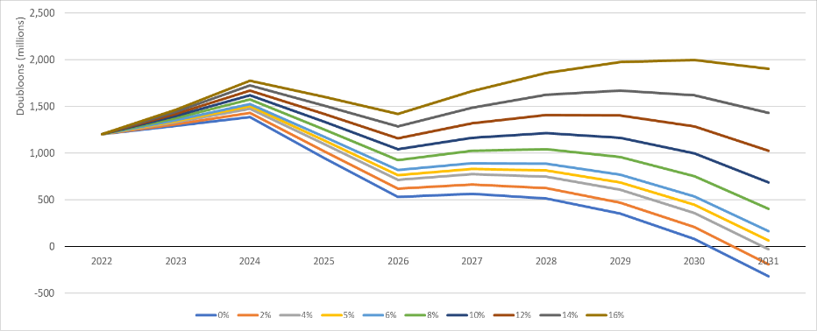Figure 4 - ROI sensitivity

As seen in Figure 5, Rarita should only be concerned when inflation exceeds 5%. The economic data provided illustrates that Rarita’s inflation has steadily decreased and was recorded as 1.32% in 2020 due to the COVID-19 pandemic. This relatively low inflation rate in 2020 is comparable to other countries, such as the US.[12] While inflation is expected to rebound globally for the next few years, Rarita’s inflation will likely settle on the historical average of 3.5%.

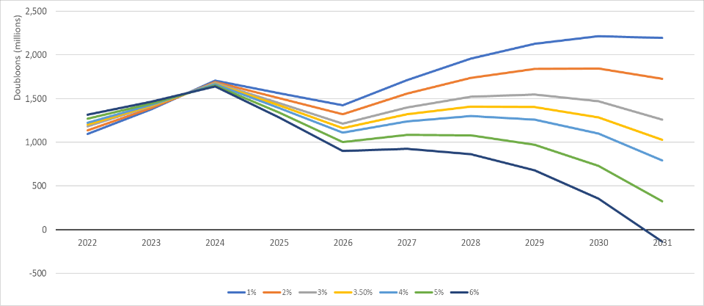Figure 5 - Inflation sensitivity

# Data and Data Limitations

The historical data provided by Rarita was leveraged in this analysis. There were the following gaps and anomalies:

* variables that should be derived from other variables do not equal the expected result (e.g., wins, draws and losses for goalkeepers do not add to 1);
* variables contain extreme outliers or unexpected negative values; or
* Does not make sense based on a broad scale (the winning team of the 2020 tournament does not having a listed goalkeeper).

*See Appendix E for how the selected model addressed these gaps and anomalies.*

Economic data lacked granularity (e.g., expenses not split by coaches and players) and indicators were not provided for other nations, which would have enhanced the cost-benefit analysis. Additional analyses that could assist Rarita in developing a competitive and financially sustainable team was limited by the lack of data on viewership demographics to form an effective marketing strategy that would boost consumer interest to increase revenues.

# Appendix

## A: Mapping of Modelling Steps to Model Type

|  |  |  |
| --- | --- | --- |
| # | Explanation | Model |
| **1** | Determine player's value based on playing statistics, position, and league (important indicator of the quality of opposition) | Gradient Boosting Machine (GBM) |
| **2** | Maximise the total value of a team whilst constraining the total player salary, number of players in a position and proportion of allocated value for each position | Optimisation model (1) |
| **3** | Apply model to different salary caps to fit a polynomial equation linking salary and value | Optimisation model (1) |
| **4** | After establishing a strong link between underlying team value and performance (Appendix B: Figure 1), determine the probability of placing top 10 using team data from the 2021 tournament (Appendix B: Figure 2) - probabilities were found by discounting the total team value back to 2021 at the superimposed inflation rate | Ordinal logistics regression model |
| **5** | Minimise the real present value (NPV) of the total player salaries each year (includes return on investment and superimposed inflation), whilst meeting the competitiveness requirement | Optimisation model (2) based on polynomial equation (linking salary and value, Appendix B: Figure 3) and logistics regression model |
| **6** | With the team budget for each year confirmed, the players were selected | Optimisation model (1) |

## B: Figures Supporting Team Selection

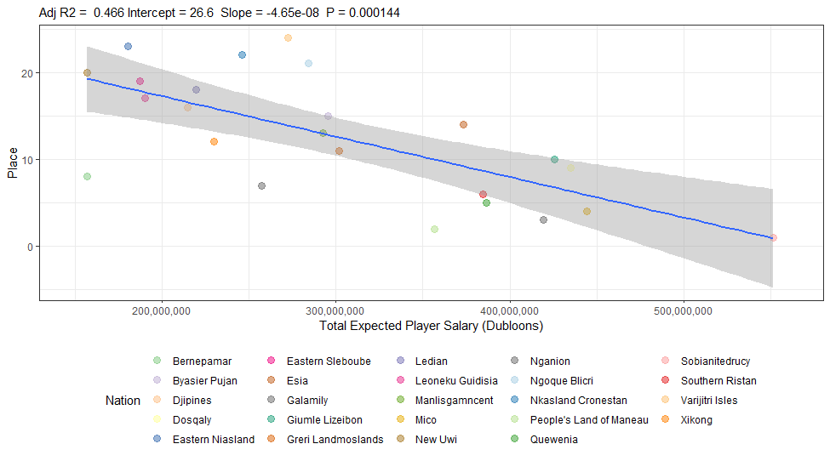Figure 1 - Player (Field and Goalkeeper) Value for 2021 Tournament Teams vs Tournament Placing

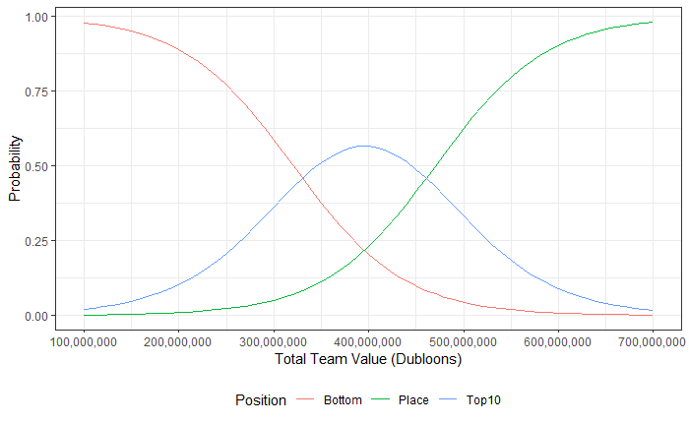Figure 2 - Total Team Value Discounted to 2021 and Corresponding Probabilities of Finishing Top 3 (Place), Top 10 but Not Top 3 (Top 10) or Outside Top 10 (Bottom)

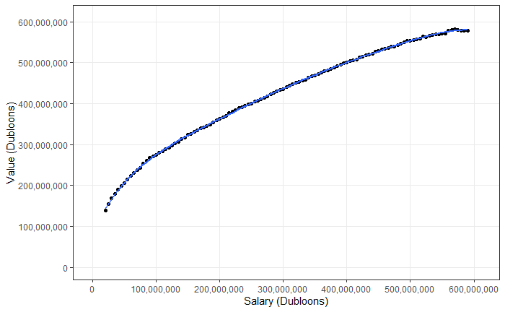Figure 3 - Total Paid Salary for Rarita National Team Players Mapped to the Total Underlying Team Value that can be Achieved (With a Fitted 6th Order Polynomial)

## C: NPV of Player Salaries for Each Year, Based on Varied ROI

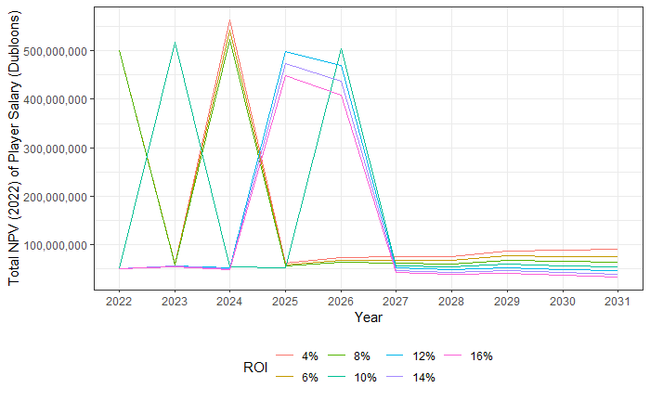

## D: Team Players

The following team was selected for 2022 is shown in the following table with respective salaries and values.

|  |  |  |  |
| --- | --- | --- | --- |
| **Player** | **Primary Position** | **Salary (Dubloons)** | **Value (Dubloons)** |
| I. Fong | MF | 3,984,074.268 | 10,671,470.45 |
| T. Darawshi | DF | 6,647,522.247 | 10,796,462.55 |
| H. Mubaiwa | FW | 1,664,460.815 | 9,921,848.792 |
| K. Shibata | DF | 1,116,663.585 | 9,195,376.329 |
| Q. bin Ismail | DF | 969,179.7153 | 8,790,593.752 |
| T. Okoro | DF | 769,023.0349 | 12,200,426.14 |
| B. Madondo | FW | 2,043,705.052 | 6,438,638.05 |
| I. Tabu | FW | 1,232,543.768 | 7,665,306.681 |
| D. Makumbi | FW | 495,124.4198 | 8,671,027.657 |
| F. Chin | MF | 1,411,631.324 | 8,572,657.264 |
| A. Hasibuan | DF | 716,350.2243 | 6,969,956.795 |
| V. Mansoor | DF | 769,023.0349 | 8,429,884.401 |
| G. Kou | DF | 1,643,391.691 | 6,935,646.293 |
| W. Barbieri | FW | 1,706,599.064 | 6,092,437.834 |
| X. Thomas | FW | 1,769,806.437 | 5,747,033.975 |
| C. Kabagambe | MF | 1,506,442.383 | 6,229,551.218 |
| J. López | MF | 790,092.1592 | 6,807,029.442 |
| K. Ramos | MF | 1,032,387.088 | 6,350,949.092 |
| S. Razaee | MF | 1,559,115.194 | 6,919,678.769 |
| H. Lo | DF | 3,434,267.252 | 9,186,238.499 |
| D. Baah | MF | 3,802,976.926 | 9,019,786.654 |
| A. Baguma | FW | 5,593,852.487 | 11,290,819.45 |
| B. Quaye | FW | 1,885,686.62 | 7,024,791.759 |
| H. Amade | MF | 1,801,410.123 | 5,828,070.125 |
| F. Ithungu | GK | 1,611,788.005 | 10,000,243.48 |
| **Total** |  | **49,957,116.92** | **205,755,925.4** |

## E: Solutions to Address Data Gaps and Anomalies

* Tree-based models were considered for the following reasons:
  + naturally account for interactions between variables, removing the need to include variables that combine the effect of two other variables; and
  + splitting will lessen the influence of imprecise data or nonsensical outliers.
* All models following the GBM were linked back to underlying player value to avoid placing too much weight on variable specifics, and 2020 tournament data was discarded for purposes of player selection.

# Bibliography

* Australian Sports Commission 2017, Intergenerational Review of Australian Sport 2017, Canberra
* Choy, L 2022, *Global M&A By the Numbers: 2021 Recap*, accessed 14 March 202, < <https://www.spglobal.com/marketintelligence/en/news-insights/blog/global-ma-by-the-numbers-2021-recap>>
* Damodaran Online 2022, *Historical Returns on Stocks, Bonds and Bills: 1928-2021*, accessed 16 March 2022, < <https://pages.stern.nyu.edu/~adamodar/New_Home_Page/datafile/histretSP.html>>
* Frontier Economics 2010, *The economic contribution of sport to Australia*, accessed 16 March 2022, < <https://www.clearinghouseforsport.gov.au/__data/assets/pdf_file/0005/855266/EconContribution_powerpoint.pdf>>

Giraud, T 2014, ‘Did the 1998 FIFA World Cup in France have positive impacts on employment?’, accessed 13 March 2022 from DiVA Portal

Roberts, A., Roche, N., Jones, C. & Munday, M 2016, ‘What is the value of a Premier League football club to a regional economy?’: *European Sport Management Quarterly*, Vol 16, No 5, pp. 575-591, accessed 15 March 2022 from Taylor & Francis, DOI: 10.1080/16184742.2016.1188840

* Toohey, K 2008, ‘Terrorism, sport and public policy in the risk society’, *Sport in Society: Cultures, Commerce, Media, Politics*, Vol 11, No 4, pp. 429-442, accessed 14 March 2022 from Taylor & Francis, DOI: 10.1080/17430430802019367

U.S. Bureau of Labour Statistics 2022, Historical Consumer Price Index for All Urban Consumers, accessed 13 March 2022, < <https://www.bls.gov/cpi/tables/supplemental-files/historical-cpi-u-202202.pdf>>

Weimar, D. & Wicker, P 2017, ‘Moneyball Revisited: Effort and Team Performance in Professional Soccer’: *Journal of Sports Economics*, Vol 18, No 2, pp. 140-161, accessed 14 March 2022 from Sage Journals Online, DOI: 10.1177/1527002514561789

1. Weimar, D. & Wicker, P 2017, ‘Moneyball Revisited: Effort and Team Performance in Professional Soccer’: *Journal of Sports Economics*, Vol 18, No 2, pp. 140-161, accessed 14 March 2022 from Sage Journals Online, DOI: 10.1177/1527002514561789
2. Although the model shows 12% ROI to be the ideal return for this strategy, this is due to granularity of the model. Logically, any return greater than the rate of superimposed inflation will make this the optimum strategy.
3. Roberts, A., Roche, N., Jones, C. & Munday, M 2016, ‘What is the value of a Premier League football club to a regional economy?’: *European Sport Management Quarterly*, Vol 16, No 5, pp. 575-591, accessed 15 March 2022 from Taylor & Francis, DOI: 10.1080/16184742.2016.1188840
4. Frontier Economics 2010, *The economic contribution of sport to Australia*, accessed 16 March 2022, < https://www.clearinghouseforsport.gov.au/__data/assets/pdf_file/0005/855266/EconContribution_powerpoint.pdf>
5. Giraud, T 2014, ‘Did the 1998 FIFA World Cup in France have positive impacts on employment?’, accessed 13 March 2022 from DiVA Portal
6. Australian Sports Commission 2017, Intergenerational Review of Australian Sport 2017, Canberra
7. Ibid.
8. Toohey, K 2008, ‘Terrorism, sport and public policy in the risk society’, *Sport in Society: Cultures, Commerce, Media, Politics*, Vol 11, No 4, pp. 429-442, accessed 14 March 2022 from Taylor & Francis, DOI: 10.1080/17430430802019367
9. Scenario 1 is projected to result in a net loss irrespective of the ROI and inflation rate assumptions, while scenario 3 is projected to always result in a net profit.
10. Choy, L 2022, *Global M&A By the Numbers: 2021 Recap*, accessed 14 March 202, < https://www.spglobal.com/marketintelligence/en/news-insights/blog/global-ma-by-the-numbers-2021-recap>
11. Damodaran Online 2022, *Historical Returns on Stocks, Bonds and Bills: 1928-2021*, accessed 16 March 2022, < https://pages.stern.nyu.edu/~adamodar/New_Home_Page/datafile/histretSP.html>
12. U.S. Bureau of Labour Statistics 2022, Historical Consumer Price Index for All Urban Consumers, accessed 13 March 2022, < https://www.bls.gov/cpi/tables/supplemental-files/historical-cpi-u-202202.pdf>